3rd Grade

Astronomy Lessons

The following is a set of suggested activities for a third grade curriculum unit on the Earth/Sun/Moon system. The goal is to provide students with an understanding of the motions of the three objects in the system and the way in which they determine the periodic changes we observe. In particular, students should develop an understanding of the way the Earth's daily rotation determines the cycle of light and dark that we call day and night; the way the Moon's motion about Earth determines the monthly cycle of lunar phases; and the way the Earth's orbital motion around the Sun determines the annual cycle of seasons. We also discuss how eclipses – solar as well as lunar – come about.

One important aspect of these notes is that we have made every effort to structure them so that students have an opportunity to observe in Nature as many of the phenomena under investigation as is possible. The challenge here is that some of these, like seasonal changes, can only be observed by making observations in different seasons – requiring that the teaching of this unit be distributed over essentially the entire school year. The activities described here are an attempt to combine the temporal requirements of observation with a sound pedagogical development of the material. A suggested timeline below demonstrates how these activities can be timed for optimal success.

Additional materials, still under development, include a unit on light, shadows, and images. Some early versions of some parts of this can be found at http://www.cgtp.duke.edu/~plesser/outreachstuff/ . Because light and shadow play such an important role in understanding the phenomena covered here, we recommend in fact that the light unit be taught before bulk of the Earth/Sun/Moon unit, as reflected in the timeline.

These cyclic changes are of fundamental importance to our lives, and their relation to celestial goings-on has been the subject of intense scrutiny – scientific, religious, and literary – in all cultures since the dawn of civilization. The literary products of our fascination with celestial motions and their meaning form an ideal literacy connection to this science unit. In an appendix we have compiled some stories from various traditions that we found particularly enriching. These are at best representative, certainly not exhaustive.

In teaching students these subjects it is natural that many questions will arise that are not addressed here, but would be natural extensions of the material included here. Examples of this are the nature and structure of the Sun and the Moon, their history and origin, the story of human exploration of space in general and the Moon in particular, etc. We have included some fragments of such information in the Teacher Background sections of the units but teachers should expect many relevant questions not answered here to come up.

The curriculum materials presented here were produced by J. Heffernan and R. Plesser. They are based on material developed by Ronen and presented at Forest View Elementary in Durham, NC by Ronen and by undegraduate students from Duke University, and were written up in their current form by John in the summer of 2003, with support from the NASA Space Grant program.

Finally, we have found that teaching this unit has been significantly enhanced by field trips to the Duke Observatory to observe some of the concepts in the sky. If observatory visits are not practical, we strongly recommend an evening meeting for naked-eye observing to render abstract concepts concrete.

Light/Astronomy unit for Third Grade
(Wishful) Timeline – 2004/5.

8/13 school starts

Draw season of your birthday; arrange pictures around classroom walls creating a one-year cyclic calendar around the class. Use this for Math tie-ins!!

Can create a connection to the cycle of hours in a day, develop a feel for what 6 pm or 3 am means. Talk about 24 hours is a day, 12 hours is half of that (day or night).

Do a Sun path measurement. Note sun should rise and set slightly North of East/West (exactly East/West at equinox).

9/7 Start 4-5 weeks of light and shadow stuff with Duke volunteers.

9/21? Equinox – provide some context.

Keep track of Sunrise/Sunset times (from papers, web) for a week as part of morning activities; keep the data for future use!

4-5 weeks of light lessons

Day and Night lesson

Reason for the Seasons.

Phases of the Moon

Eclipses

10/27 total lunar eclipse

Convert wall calendar into Earth orbit, referring to previous discussions.

12/10 Do a Sun path measurement. Note Sun should rise and set South of East/West.
Shadow of Time

Keep track of Sunrise/Sunset times (from papers, web) for a week as part of morning activies; keep the data for future use!

12/20 Solstice – can discuss meaning of this in more detail.

Keep track of Sunrise/Sunset times (from papers, web) for a week as part of morning activies; compare the three sets of data from three seasons.

3/21 equinox – final summary of seasons, orbits, etc.

List of Activities

- The Sun Moves in the Sky: Examination of the Sun’s movement through the sky.

- Shadows of Time: Using a stick’s shadow to examine the Sun’s movement and the passage of time.

- Day and Night on the Spinning Globe: Exploration of the how and why of darkness and light.

- Reason for the Season: Discover the causes behind our seasonal changes.

- Phases of the Moon: Each student will create the phases of the moon.

- Where did the Moon Go? The story behind eclipses and who’s in the way of whom.

Daily Classroom Routines

One of the most powerful and productive tools to help students internalize the rhythm of the cyclic processes, as well as the intricate three-dimensional geometry that governs them, uses daily classroom routines that track the various changes. Depending on taste, available time, etc. individual teachers can pick and choose among the following recommended activities.

- Chart sunrise and sunset times. These are available in local newspapers or online. Keeping the charts allows students to keep track of the changing length of day. This need not be done throughout the year, a sample of a few days near fall equinox, a few days near winter solstice, and a few near spring equinox should be sufficient to demonstrate the pattern.

- Record daily high and low temperatures. Keeping track of these helps monitor the seasonal changes.

- Record Moon phases, moonrise and moonset times. The periodic changes in these, and the correlation between them, help demonstrate one of the trickier aspects of understanding how phases occur.

- Construct an Earth calendar in the classroom. This exercise is very useful in helping students visualize the three-dimensional geometry involved in daily, monthly, and annual cycles. Imagine that the Sun is located near the center of the room. Some teachers have realized this by hanging a papier-mache Sun from the ceiling at the appropriate point. A globe, mounted so that it can be moved around the room along the walls, will represent the Earth moving in its orbit about the Sun. One wall will roughly correspond to each of the four seasons (there is usually one wall – with cubbies, door, etc – along which the globe should not be positioned, and selecting this to correspond to summer is a good idea). To begin with, therefore, you will need to mark off along the walls locations corresponding to dates in the year. The Earth moves about 1º along its orbit every day (more precisely it moves 1/365 of a 360º circle per day), so marking off every 7º along the wall provides one mark a week. The globe should be mounted with its axis tilted so the North pole points in the direction of the wall corresponding to winter, and kept that way as it is moved. The daily, or weekly, activity of moving the globe along the orbit helps students recognize the relation between the Earth's orbital motion and seasonal changes. It is also helpful to mark the classroom's location on the globe and rotate the globe to a position corresponding to the correct time of day.

The Earth calendar can be extended and enhanced in various ways. Students can decorate the walls with pictures depicting the corresponding seasons; each student can produce a picture depicting the season in which his or her birthday occurs, and these can be placed along the walls in the appropriate place. Also, to demonstrate how the night sky changes over the course of the year, models of the constellations of the Zodiac can be positioned on the walls in locations corresponding to their position in the sky (constellations of the Zodiac are located in space near the plane of the Earth's orbit and the time of the year to which each is associated by astrologers the Sun and the relevant constellation are approximately aligned as seen from Earth). From any position along the orbit, the stars that are visible will be those on the “night” side of Earth, away from the Sun.

When learning about lunar phases the model Earth can be endowed with a model Moon (a white ball, smaller than the globe) mounted so it can be rotated about the globe. The daily activity can now be extended to include setting the Moon in its correct position relative to Sun and Earth as determined from its phase.

Many other extensions can be created, these are a few that have been successfully applied at Forest View.

Glossary
Enchanted Learning’s Astronomy Glossary located at:
http://www.enchantedlearning.com/subjects/astronomy/glossary/index.shtml

Teacher's Background

Setting and Scales

The cycles of day and night, seasons, and lunar phases are all governed by the relative motions of Earth, Sun and Moon in space. The Earth is a roughly spherical object, of radius about 6400 km. Its shape, which crucially affects all the phenomena we study, was first deduced by Aristotle from the fact that Earth's shadow on the Moon appears rounded whenever it is visible (during a lunar eclipse, see below) and the geomtric fact that a sphere is the only shape that projects a round shadow when illuminated from any direction. Eratosthenes in fact made a roughly correct measurement of the radius around 400 BC, though this knowledge was forgotten by Europeans for centuries.

Surrounding the Earth is a thin layer, about 150km thick, of air, the atmosphere. The fact that we live our lives within this envelope makes thinking about the emptiness that comprises the great majority of the Universe a bit confusing. On Earth, light from the Sun or from any other object scatters off objects around us or off impurities in the air. Thus, we are bathed in light from all directions. In the emptiness of space, with nothing to scatter it, light from the Sun, for example, streams away from the star in straight lines. An astronaut in space looking at the Sun would be blinded by its brightness, yet the sky near the Sun would appear black except for the pinpoints of distant stars. Images taken during the lunar day, in which the surface and objects on it appear brightly illuminated by the Sun, yet the sky is dark, are a powerful example of this – the Moon is too small to bind an atmosphere.

Light in the vicinity of Earth arises mostly from the Sun, a rather average star with a radius of some 690,000 km and a surface temperature of 5800K. The interior of the Sun is heated by nuclear fusion (the same process that powers Hydrogen bombs) to much higher temperatures of some 1.5 million K, and the energy produced by fusion is radiated from the surface as light and heat. Some 150 million km from Earth, the Sun is by far the brightest object in the sky because it is the nearest star to us by far. The next nearest star is 300,000 times farther.

One of the challenges of learning and teaching about space is that distances, sizes, and times involved are so large as to defy intuition. To gain some sense of scale, it is helpful to consider a scale model of the Solar system in which the Earth is represented by a ball of radius 6.4cm (about the size of a grapefruit). At this scale, the Sun – 10000 larger in radius – would be represented by a ball of radius 700m (about half a mile) at a distance of about 15km (10 miles). The next nearest star would then be 3 million miles away, ten times farther than the distance to the (real) Moon.

In thinking about space students are also often confused by common sense assumptions acquired in their life on Earth's surface. On Earth, we are surrounded by the atmosphere, while most of space is to a good approximation an empty vacuum. We are all aware that this makes breathing in space impossible, but the atmosphere affects our experience in other ways as well. The one most pertinent here is the fact that light – from the Sun or artificial sources – is scattered by impurities in the atmosphere: dust, water, ice, etc. This is the reason our daytime sky is a luminous blue (see the light unit notes). Typically on Earth, we are also surrounded by other objects. These reflect light, with the result that we are “bathed” in light from all directions. In the emptiness of space, with nothing to scatter or reflect it, a beam of light will propagate in a straight line for great distances: this is what enables us to see distant stars or galaxies. This also means space is dark, even in the vicinity of a bright object like the Sun. Any object reflecting the light will appear luminous against the perfectly black backdrop of space. This is why planets, and the Moon, appear to shine brightly in the night sky.

Another common misconception is that motion requires propulsion. This is a natural conclusion to draw from our experience on Earth's surface, where friction and gravity dominate. Nothing moves unless we move it, and left to their own devices objects quickly come to rest on the ground. In fact, a moving object upon which no forces act continues to move at a constant speed. Objects slow to a standstill on Earth due to the forces created as they move through surrounding air, or over the ground. In space, absent air or ground, perpetual motion is the natural state of things.

Gravity, Orbits, Motions, and Origins of the Solar System

The motions – and shape and structure – of astronomical objects are primarily determined by the action of the force of gravity. This is the universal attractive force that any object applies to any other object in the Universe. The gravitational force between two objects is proportional to the product of their masses, and inversely proportional to the square of the distance between them. Thus, the force applied by the Earth to various objects on its surface, which we call weight, grows larger the more massive the object in question. The force applied to those same objects by an ant, while nonzero, is too small to be measured because the mass of an ant is so small. Similarly, the force applied to objects by a distant galaxy is negligible despite the galaxy's great mass due to its immense distance.

The force of gravity causes an unsupported object to fall to the Earth. Yet the Moon, unsupported, has avoided this fate for billions of years. Moreover, orbiting satellites do not fall, though they lack any jets or other means of propulsion (this is often misunderstood). While it is true that gravitational forces weaken with distance, this is not the reason. The Moon, spaceships, and satellites, avoid falling to Earth because they are orbiting it. In essence, all these objects are falling to Earth but since they are also moving around Earth they manage to “fall” while maintaining a constant distance from the planet. One can explain the motion of an object in orbit as a continual fall in which the Earth (or whatever is being orbited) is forever being “missed” and “overshot.” In this way the Moon is forever falling to Earth as it orbits, while Earth and Moon together are falling to the Sun as they orbit it.

Under the influence of gravity, a primordial nebula, a cloud of gas and dust, collapsed inward upon itself to form what we now call the Solar system some 4.5 billion years ago. As the nebula collapsed, two important processes occurred. Like an ice skater pulling in her arms to initiate a twirling spin, the slight, random rotational motion of the nebula accelerated and became a pronounced overall rotation. As the rotation accelerated, the nebula flattened out into a disk. The rotation as well as the orbital motion of most objects in the Solar system reflect this original rotation. For this reason all the planets orbit the Sun in approximately the same plane and in the same direction; the Sun itself, as well as most of the planets, revolve about themselves in approximately the same plane and in the same direction; the Moon orbits Earth in approximately the same plane, etc. For example, this is the reason that all planets, the Moon, and the Sun show up in the sky on or near an imaginary circle – the shape of this plane from the point of view of someone like us who is inside it – called the ecliptic.

As the gas and dust became more dense, collisions between particles heated it up. Most of the matter in the nebula ended up forming the star at its center – the Sun. This densest part of the nebula was also the hottest, and eventually at its center temperature and density were sufficient to initiate the process of nuclear fusion. Material left over from the formation of the Sun continued to orbit the nascent star, and this eventually coalesced – driven once more by gravitational attraction – into the planets. The condensation of gas and dust into a dense planet heated the material to melting. Initially the Solar system contained hundreds of small “planetesimals.” Some of these merged to form the planets, others were ejected from the system by collisions, so that by 3 billion years ago interplanetary space had become almost empty. Our leading theory of the Moon's origin involves a collision between the Earth and a Mars-sized object during this early phase, in which parts of both colliding objects were ejected into orbit where they eventually coalesced into our Moon.

Like most large celestial objects, the Earth, Sun, and Moon are roughly spherical in shape. The reason, in the case of the Sun, is that the star is made mostly of gases (Hydrogen and Helium principally) held together by the force of gravity. Deviations from a spherical shape would be erased by gravity. Imagine attempting to raise a mountain of water in the middle of the ocean. It would be destroyed by gravity. On a larger scale, this is the mechanism that maintains the Sun's shape. In the case of the Earth, Moon, and planets, their shape is an indication that at one point they, like the Sun, were fluid in composition. Indeed the primordial Earth was a much hotter body than it is today and was mostly molten; it was at this time that it acquired its nearly spherical shape. Smaller asteroids, which never became hot enough to melt as they formed, have a variety of shapes and are not in general spherical.

Deviations from a perfect sphere are also instructive. Rotating bodies are usually oblate – thicker about their equator than a perfect sphere would be. This is certainly true of the Earth and of the Sun. Extreme cases of this occur in larger bodies such as the Solar system as a whole or our Milky Way galaxy, which have been flattened to disks by their rotational motion.

Another important deviation is due to the fact that gravitational forces on a large object are not uniform. For example, the Moon's mass applies a gravitational force to all objects on Earth. This force is strongest at the point on Earth nearest to the Moon, and weakest at the point farthest from the Moon. The average attraction, which causes a small orbital motion of the Earth as a whole, has little effect on us, but these differences – tidal forces – which tend to draw Earth out into an elongated shape with the axis pointing at the Moon, have a profound effect. The Earth is too rigid to be deformed much, but water can flow on its surface, and the bulges on two opposing sides of Earth are locations of the twice-daily high tides. The tidal forces on the Moon due to the variation in the strength of Earth's attraction caused the early, fluid Moon to be slightly deformed. The Moon is indeed somewhat oblong, and rotates as it orbits Earth so that its longer axis always points towards the planet, much like a visitor walking around a museum exhibit, keeping her face towards it as she moves. This is the reason we see the same side of the Moon at all times.

The Sun is the main source of energy in the Solar system. Energy emitted by the Sun as light and heat is the source of heat and light on Earth as well as the reason the Moon and planets are visible. Unlike stars, these cooler objects do not produce energy and do not emit light. We see them in the dark night sky because they reflect Sunlight. For the Earth/Sun/Moon system, this means that the relative positions and orientations of the three objects drive a set of cyclic changes as perceived from Earth. These changes are the essential core of these lessons. The changes in relative positions and orientations occur on three different timescales: a 24-hour cycle governed by the Earth's rotation on its axis; a monthly cycle governed by the Moon's orbital motion about the Earth; and an annual cycle governed by the Earth's orbital motion about the Sun. Because of the different timescales involved, we can treat each motion ignoring the slower ones. This means that for the purpose of understanding daily changes the motion of the Earth about the Sun, and of the Moon about the Earth, in the course of one day can be ignored. For the purpose of discussing the Moon's orbit about Earth we can at first ignore the fact that Earth moves about the Sun: it moves little in a month.

Daily Cycle: Rotation of the Earth

The fastest cycle is the daily rotation of Earth about its axis from West to East. The main result of this is that to an observer on Earth all objects in space seem to be moving in circles from East to West. This is helpfully thought of as the same effect that makes the scenery seem to whirl around an observer who is riding a merry-go-round. As the Earth rotates, objects in a given direction in space are revealed above the Eastern horizon (more precisely the horizon drops below them), arc through the sky, and are eventually obscured by the rising Western horizon (set). Note that this is true for moderate latitudes. At the poles, objects neither rise nor set as the Earth rotates, but move in horizontal circles in the sky. A given star (direction in space) is either always visible or always below the horizon at the pole. At any latitude, the sky moves as though hinged on an axis parallel to Earth's axis. At the equator this is horizontal, at the poles vertical. At intermediate latitudes the axis is angled to the horizon. Of course, the axis is fixed, and its differing orientations relative to the horizon reflect the curvature of Earth. What you consider vertical depends on where you are on Earth.

Stabilized like a spinning top, the axis about which the Earth spins is fixed. This means if you stand at the North pole and look straight up you will see the same part of the sky (the vicinity of Polaris, the Pole Star, at all times. Our discussion of the history of the Solar System above would suggest that the Earth's rotation and its orbital motion about the Sun be in the same sense, as both are descended from the primordial rotation of the Solar nebula. This is approximately true. In fact the axis about which Earth revolves is tilted by about 23.5º from the axis about which it orbits. The same is true, to varying degrees, of all the planets in the Solar system, reaching an extreme case with Uranus, whose axis lies almost in the plane of its orbit. These deviations from our expectations likely reflect violent collisions early in the history of the system.

Most dramatic, of course, is the rising and setting of the Sun, which determines the daily cycle of light and dark at every point on Earth. Because this reflects the rotation of a round planet, different places on Earth face the Sun at difrerent times during the rotation. We all set our clocks so that the Sun will be at its highest point in the sky around noon, hence the need for time zones around the Earth. Another effect of this rotation, mentioned above, is that as different parts of Earth face the Moon, water on the surface moves in response to tidal forces leading to twice-daily tides. Because of the Earth's rotation, in fact, the high-tide axis is dragged “ahead” of the Moon's position – tides are highest at the points that faced toward the Moon or away from it several hours earlier.

An interesting fact is that the axis about which Earth rotates is not, in fact, completely fixed. Like a top tilted relative to the vertical, the Earth “wobbles” slightly, so that its axis maintains the 23.5º tilt but “precesses” in a cone about the orbital axis. This means Polaris has not always, nor always will be, our “pole star.” Ancient Egyptian remains show that the star Vega was the pole star 5000 years ago. The wobble is quite slow, however, the rotational axis completes an entire circuit about the orbital axis every 26,000 years or so. Polaris is thus going to remain our Pole Star for quite a while. The slow change is referred to for historical reasons as “the precession of the equinoxes.”

Annual Cycle: Earth's Orbital Motion

The orbital motion of Earth around the Sun, which takes about 365 days and comprises a year, has several effects as well. Most obviously, it means that over the course of the year the direction from Earth to the Sun changes. This means that when we look up at night – which means we are looking away from the Sun – we see different stars in each season. This can be made real for students by posting pictures of the constellations on classroom walls. The constellations visible in the spring would be on the wall near which the globe would be in spring. In the fall they would lie behind the Sun as viewed from Earth and not be visible at night. Stars located on the ceiling (near the North star) would be visible in all seasons.

A less obvious effect of the orbital motion but by far the most important one for us, is related to the fact that the Earth's axis (imaginary line running from South to North pole, about which Earth rotates) is tilted relative to the plane in which the Earth orbits the Sun. As the Earth orbits the axis points in the same direction at all times (this direction is the direction to the North star which is why that star is always found North). To understand the effect of this tilt is easiest if we consider two extreme cases, neither of which is in fact true.

Consider first what would happen if Earth's axis did not tilt at all. In the classroom model, this would mean mounting the globe with its axis vertical. Note that at any point along the orbit one half of the Earth's surface is illuminated by the Sun and one half is in the shadow of Earth. As the Earth rotates, each point on the surface (except the poles) moves in a horizontal circle so spends one-half of its time in the illuminated side and one-half in the dark. Sunlight thus lasts 12 hours everywhere throughout the year. Seasonal variation is completely absent.

On the other hand, consider what would happen if Earth's axis were in the plane of the orbit (horizontal in our model). (This is in fact the case for Uranus.) Remember that the axis points in the same direction throughout the orbit. The circles along which points move with the Earth's rotation are now vertical. Thus, at one point in the orbit the North pole would face the Sun. At the time of year corresponding to this point in the orbit, the Sun would never set in the Northern hemisphere and would never rise in the Southern hemisphere! At the opposing point on the orbit the roles of the two hemispheres would be reversed. Seasonal variations would be very extreme. When the Northern hemisphere faced the Sun, and all points North of the equator enjoyed continuous Sunlight, the weather in the Northern hemisphere would be quite warm, while the Southern hemisphere, with no Sunlight at all, would be cold. In fact, the region near the North pole would be warmest. This seems intuitive, because it faces the Sun directly.

A more precise explanation is that near the point on Earth's surface nearest to the Sun, Sunlight will be impinging the Earth vertically, while closer to the equator sunlight is impinging at larger angles. This is most easily visualized by placing yourself in the Sun's position and looking towards Earth. You can see that from this point of view, features near this point seem larger than features just visible near the edge of the visible disk. The latter are “foreshortened by perspective,” and look smaller to you. Features that look larger to you – take up more of your range of vision – would correspondingly take up more of the incoming Sunlight. It is important to note that this has nothing to do with the actual distance to the Sun, is rather related to the curvature of the Earth and the angle at which Sunlight impinges on the surface.

In fact, the Earth is intermediate between these two extremes. Its axis, as is well known, is inclined by approximately 23.5º to the (perpendicular to) the plane of the orbit, leading to mild seasonal variations in climate. When the Northern hemisphere faces the Sun, it is warmer in Northern regions of the Earth – summer in the Northern hemisphere is winter in the Southern hemisphere. There is a common misconception that summers are warmer than winters because Earth is closer to the Sun in the summer. This is quite false, as demonstrated by the fact that Northern summer coincides with Southern winter, but may be best corrected by noting that in fact the Earth is marginally nearer the Sun in January than at any other time of the year.

Monthly Cycle: Moon Orbits Earth

Intermediate in timescale between the daily rotation of the Earth and the annual orbital motion is the Moon's motion as it orbits Earth once every 29 days or so. The effect of this on the Moon's appearance to us is to create the familiar phases. The Moon is visible to us, as mentioned above, because reflecting Sunlight it appears luminous against the backdrop of empty space. The Moon does not, however, create its own light, so that we can see only that part of the Moon illuminated by the Sun. At any instant, the Sun illuminates precisely one half of the Moon's surface (just as it illuminates one half of Earth's surface). Similarly, at any given time we on Earth have an unobstructed line of sight to precisely one half of the Moon's surface. What we actually see of the Moon is that part which is simultaneously illuminated and visible.

When the Moon and Sun are in approximately same direction from Earth, the illuminated side of the Moon is the side facing away from Earth. The side facing us is dark and the Moon is invisible – a New Moon. Note that because this phase occurs when Moon is in same direction from Earth as the Sun, a new Moon rises and sets at the same time as the Sun. Conversely, when the Sun and Moon are aligned in opposite directions from Earth, the illuminated side of the Moon – the side facing the Sun – is also the side facing Earth and visible. Hence we see an entire bright disk in the sky – a Full Moon. Because this phase occurs when Sun and Moon are in opposite directions as seen from Earth, a full Moon always rises at sunset and sets at sunrise. Intermediate phases occur between these points.

Because the Moon orbits Earth in the same sense as the sense in which Earth rotates – West to East – it rises later, by approximately 48 minutes, each day than it did the day before. The new Moon, rising at sunrise, is thus followed by a waxing crescent Moon which rises later and later as it waxes from day to day. When the Moon and Sun are 90º apart in the sky, one-half of the side of the Moon facing us is illuminated, and we see one-half of an illuminated disk in the sky. This is called waxing quarter Moon, and from what we have said a waxing quarter Moon is seen to rise around noon (and set around midnight). When more than half of the disk is seen, as the Moon continues to orbit away from the Sun, we have a waxing gibbous Moon rising in the afternoon and setting in the early hours of the morning.
The full Moon is followed by waning gibbous phases, with the Moon rising later and later at night, until the waning quarter Moon, when once more we see half a disk, which rises at midnight and sets at noon. This is followed by waning crescents, rising later and later in the early morning until the new Moon recurs.

The Moon does not, in fact, orbit Earth precisely in the plane of Earth's orbit of the Sun (the ecliptic). It orbit is in fact tilted slightly (5º approximately), and like the Earth's axis it precesses. The result of all this is that the Moon is “above” (North of) the ecliptic for half of its orbit and “below” (South of) the ecliptic the other half, meeting the plane at two points located at opposite sides of the orbit (the nodes). When the orbit is oriented so that these points line up with the points on the orbit at which the Moon is new and full (we say “the line of nodes points at the Sun”) the new Moon can obstruct the Sun as seen from Earth, and Earth can obstruct the Sun as seen from the full Moon. This is when eclipses occur.

A Solar eclipse is possible due to the coincidence that the Moon, some 400 times smaller in diameter than the Sun, is also some 400 times closer to Earth. Thus both objects appear about the same size in our sky. When the full Moon intesects the ecliptic, it will cast a shadow on Earth. In fact, only in a small region on Earth (a few hundred miles across) will the alignment be perfect and the Sun totally obstructed. In this region, daytime will darken dramatically. With its luminous disk hidden from view, the outer layer of the Sun's atmosphere – the corona – will be visible. Surrounding this small region – called the umbra – is a larger region in which the alignment is imperfect and the Sun partially obscured – the penumbra. In this region, the Sun's disk appears partially obscured. Sometimes, when a Solar eclipse occurs when the Moon is at a position in its elliptic orbit at which it is slightly farther from Earth than its average distance, so that it appears somewhat smaller in the sky, it fails to completely cover the Sun and a ring of the Solar surface is visible around the darkened center, in an annular eclipse. Of course, during the hour or so that the eclipse lasts, the rotation of the Earth will have caused an extended swath of the surface to sweep through the umbra. Observers outside the penubmra will not observe anything unusual at all during a Solar eclipse. The new Moon will be invisible, and the Sun will shine as usual.

A lunar eclipse occurs when the full Moon is in the plane of the ecliptic, hence in the Earth's shadow. As with a Solar eclipse, the more common penumbral lunar eclipse occurs when the Earth only partially obscures the Sun (as seen from the Moon). Seen from Earth, the Moon darkens slightly, often almost imperceptibly. More dramatic are umbral eclipses, when the Earth obscures the Sun entirely (as seen from the Moon). Note that because the Earth is larger than the Moon, its umbra is large enough to cover the entire surface of the Moon and darken it completely. During a total lunar eclipse, the Moon darkens dramatically, and reddens (the redness is caused by light from the Sun reaching the Moon after traversing Earth's atmosphere, grazing the planet. As the Sun appears red at sunset when its light traverses a large distance through the atmosphere before reaching our eyes, so the light reaching the Moon is reddish, causing the Moon to appear red). Less dramatic partial eclipses occur when the full Moon lies slightly above or below the ecliptic, so only its lower, or upper, part is darkened.

The Sun Moves in the Sky

Purpose:

Our understanding of the cyclic changes all around us begins, historrically and conceptually, with observations. The most immediately accessible is the daily cycle of night and day, and more specifically the daily motion of the Sun across the sky from East to West. This is an important regularly repeating phenomenon, and formed the basis of ancient cosmologies, in which much effort was devoted to the question “what moves the Sun in the sky, and why, and where does it go when it sets.”

Our understanding of this phenomenon changed dramatically with the discovery that the Earth is round, and that sunset is a local phenomenon. The Sun, when it sets, does not disappear, it is shining elsewhere on Earth. Today, we think of the daily motion of the sky
from East to West as reflecting the rotation of the Earth itself from West to East. It may be useful to point out that it is completely possible to think of the Earth as stationary, provided one considers not only the Sun but the entire Universe to revolve around us. This point of view is not popular among scientists and leads to a more complicated description of the motions of objects, but fundamentally it is equivalent to the standard approach, described as seen from Earth. Somewhat pompously, one can say that Einstein's theory of Relativity which shows that there cannot be a “correct” point of view from which to describe motion, that in fact all points of view are equally valid, tells us a cosmology in which the Earth is stationary is perhaps less simple but no less valid than one with a rotating Earth. This may be a comfort to some students.

The three dimensional motions of Earth and other objects are conceptually challenging, and we will build towards an understanding of them gradually. In this first activity we are going to collect observations, as the ancients did, without at first worrying about interpretation. In this first activity students will observe and record the Sun's apparent motion through the daytime sky. The most important property of this motion is its regular periodicity, repeating very reliably every 24 hours.

By repeating this activity three times during the year in three different seasons (fall, winter and spring), the students' data will reveal the seasonal changes in the Sun’s overhead path and when compared will ‘shed light’ onto how the Earth’s tilt on its axis and orbital motion around the Sun create the seasons.

Materials:

  - Compass
  - 3’x 6’ sheet of paper for large horizon representation
  - Digital camera or panoramic camera
  - Yellow construction paper for cut-out Suns
  - The Sun’s Path Across the Sky sheet generated by teacher
- Class list with students divided into groups of fours to be “Sun Trackers”

The Sun Path Chart
(Taken from Washington State University, Energy Program at http://cru.cahe.wsu.edu/CEPublications/eb1857e/eb1857e.html)
The sun path across the sky is a function of two things: the earth's daily spin and its annual orbit about the sun. On December 21 the sun path is at its lowest altitude and of shortest duration. (See Figure 5.)
Figure 5
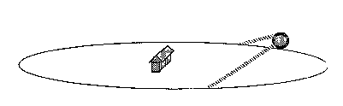
Lowest winter sun path.

As summer approaches, the sun path gets higher and of longer duration until it peaks on June 21, the longest day of the year. The sun path attains its highest altitude at midday. (See Figure 6).
Figure 6
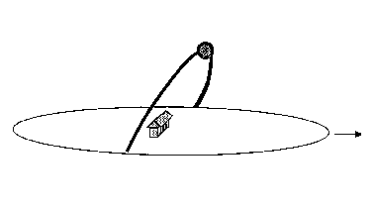
Highest summer sun path.
After June, the sun path gets lower and the days get shorter until the cycle is completed on December 21 and begins all over again.

By facing south it's possible to visualize the paths the sun follows on the 21st day of four months of the year and generate a graphic representation of the sun's various positions in the sky. (See Figure 7, page 5.)

Figure 7
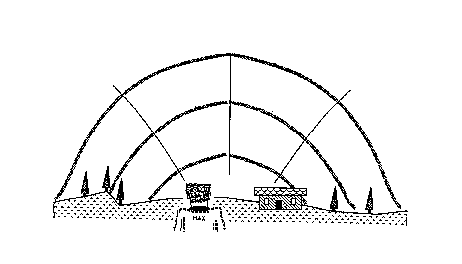
Three specific sun paths.

Developmental Issues:

Eight and nine year olds are becoming more adept at holding and comparing two different objects in their mind when problem solving. The use of a physical Earth-Sun model is critical in the students’ attempts to visualize and remember the Earth-Sun system. Eight and nine year old students are becoming competent at collecting information and representing data pictorially in order to interpret what was observed and recorded. Lastly, cooperative teamwork is advancing to a point where academic problem solving can be aided by providing specific roles for students within a team structure.

Inquiry Activity

Activity Preparation:

a) The day before the activity go out to the location where you will have the kids draw their Sun drawings and use a compass to locate the direction of magnetic South. Find a location that has an expansive view of the southern horizon from East to West, that is not shaded at any time of the day, and to which you can return every hour throughout the school day. Note that the Sun should appear due South around Noon but not exactly at Noon due to daylight savings, seasonal variations, and our longitude. Mark an arrow on the ground with chalk pointing South and be sure to have the kids facing South the next day.

b) Take a series of photos (digital, panoramic disposable, or 35mm will do fine) of the horizon where the students will be drawing. Attempt to piece together your photos and print out a representation of the horizontal landscape that your students will use to help keep track of the Sun. Ideally, print out your landscape onto an 8”x11” piece of paper for each child to use as their “The Sun’s Path Across the Sky” sheet and also duplicate the outline of your landscape onto butcher block paper that’s about 3’ x 6’ for the entire class. The large horizon representation will be mounted in the class for your student to use as groups record their hourly observations.

c) If you are unable to make a photo representation draw a free hand representation of the horizon from your observation location. Be sure to make distinct landmarks on the landscape. (e.g. trees, buildings, etc…). Create an 8”x11” horizon recording sheets for your students and a large 3’x6’ horizon representation to be mounted in your classroom.

d) Divide your class into groups of four students to be “Sun Trackers”

Activity:

- Early in the school day, possibly in your morning meeting, ask your students, “Did anyone see the Sun this morning as you were coming to school?” As you see hands rise ask the follow up question of “When you were in the bus, in the car, or walking outside where in the sky would you describe the Sun was located? Close to the trees and building or higher up in the sky more straight overhead away from the trees and buildings?” “Does anyone see the Sun in the morning close to the same place each day?” “Does the Sun stay in the place you saw it in the morning all day long?” “What is going on?”

- Describe to the students that today they will be drawing the path or movement of the Sun in the school day sky. Noticing and drawing the Sun’s path has been done by scientists for thousands of years and has lead to many discoveries. Let’s see what discoveries your students’ drawing and discussions led to in this activity.

☼Prior to going outside clearly explain that we will find out the Sun’s place in the sky without looking directly at it, not even for a glimpse. Describe the safety hazards of looking directly at the sun. ☼

- Explain the importance of drawing or recording what we notice today about the Sun’s path so that others can understand what we saw and discovered. Hand out copies of the “The Sun’s Path Across the Sky” recording sheet you have drawn or photographed. Describe how you drew or photographed the horizon and the importance of making the horizon representation accurate so their collected data or recordings are accurate.

- Have your students gather a pencil, clipboard, and their “The Sun’s Path Across the Sky” recording sheet and travel to your outdoor observation location. Be sure to have your own clipboard, pencil and recording sheet. Once at your location, have everyone face the south. Explain the need to have the same viewpoint so we can draw and talk about the same thing. Brainstorm ways they can connect where the Sun is in the sky by noticing or feeling the Sun as it relates to other objects. Possible suggestions include: seeing shadows, feeling warmth on the right or left side of your face, and noticing a landmark on the horizon. Explain to the students they will be following the Sun’s path along the horizon in the South. Define the horizon as the place where the Sky and Earth meet. Discuss the objects that are on the horizon especially the heights and shapes of different trees and buildings. Have them compare what they see in the actual horizon to what is on their representational “The Sun’s Path Across the Sky” recording sheet. Describe the importance of landmarks on the horizon in identifying where the Sun is in the sky. Teach your students how to measure the height of the Sun above the horizon using their fists. Model how to place one fist vertical or thumb up on the horizon and continue to alternate fists, counting up until you reach the bottom of the Sun. Next draw the Sun in the sky where everyone agrees it to be. Record the time above the sun and return to the classroom.

- Once in the class, discuss how the Sun they drew was a model. Explain how what we observe and record outside will be duplicated or copied onto our larger 3’x6’ horizon representation in the class. Explicitly show how the enlarged landscape model in class is similar to the smaller “The Sun’s Path Across the Sky” sheet. Ask for a volunteer to place a pre-cut out yellow construction paper Sun in the place where they recorded the Sun to be in the sky. Be sure the student labels the recording time above the Sun and describes what landmarks he/she used to decide where to exactly place the Sun. Ask the class, “If you go out and draw the Sun’s position in one hour, how will its position be different from out first drawing?” “Why will it be different?” Have groups of students discuss their predictions together and be prepared to share their thinking with the class. Invite one student from a group to come up and place a new pre-cut yellow construction paper Sun in the place where the Sun will be in one hour. Ask them to explain why they think the Sun will be in this location.

- In one hour, have the first group of “Sun Trackers” (a group of four students) return to the exact location outside to observe and record the Sun’s new location in the sky on their “The Sun’s Path Across the Sky” sheet. Explain the importance of accuracy and using the landmarks to assist in locating the Sun’s location. Instruct the “Sun Trackers” that they will need to locate and draw the Sun’s position in connection to a landmark or object on the horizon and record the exact time of their observation. Once back in the classroom after their outdoor drawing, gain the class’ attention and ask the group that returned from outside, “How did the group’s predictions an hour ago match where the Sun is now?” Next ask them, “Where do you think the Sun is going to be next hour and explain your thinking?” and have them place a new pre-cut out sun on the large sheet.

- Have a new group of “Sun Trackers” go out each hour and make a drawing of the Sun’s location in the sky above the horizon. After each group returns follow the same steps as outlined above in #6. Each group observes, records, predicts and explains. After several drawings a definite shape is forming from the Sun’s path. Ask, “What type of shape is the Sun’s path making and how would you describe it?” Listen for what names the children give to describe the Sun’s arc. Additionally ask, “What shapes can be made from the Sun’s path? Half-circle? Circle?”

- Finally ask, “”What happens to the Sun at night?” Students will probably come up with several explanations, among them the correct one – that it is shining elsewhere on Earth's round surface. At this time it is not necessary to provide a “right” answer, and a serious discussion of the merits of whatever proposals they make is probably the most productive approach. The idea here is to present the problem, pique their curiosity, and start them thinking about it. Promise that the subject will be pursued further later on.

- After completing the entire day’s observation keep the large The Sun’s Path Across the Sky up for display in the class. If you have a South-facing window try to make the Mid-Day marks outlined below.

Class Noon-Line Project
Another project could be making a window Noon Line. This was a device used by farmers in Skåne, Sweden to mark Midday. Find a south-facing window, which has several panes of glass. Notice how the solid framework between the panes casts shadows onto the window sill. When the Sun is at its highest point (at Midday) you can mark the line of the shadow cast by the pane frame with masking tape. This effectively turns the window into a simple sundial. Whenever the shadow of the pane frame matches the line of tape that means it is Midday.

Shadows of Time:
Using a stick’s shadow to examine the Sun’s movement and the passage of time

Purpose:

We will extend discovering connections between the path of the Sun across the sky and the passage of time using direct observation and recording. While the last activity helped solidify our understanding of the Earth’s shape and movement, this activity will continue to use the Sun’s path across the sky but this time so we can make accurate measurements of its path. The measurements will keep track of the stick’s shadow and allow us to read a sun clock. The sun clock will enable students to visually understand the relationship between the sun’s motion and our concept of time.

Optimally, you should do this activity three times during the year. Allowing your students to record the changes in the sun’s movement during three different seasons translates into understanding the tilt of the Earth on its axis and its relation to the differing amount of sunlight hitting the Earth. The three recommended times are:
- In the late fall after you have taught lessons on the properties of light
- Mid-February (approximately two months from start date)
- Late April or early May (four months from start date)

Materials:

-stick (an old broomstick works if cut approximately to 1’6” long) secured in a coffee can of stones or something to secure it
-4’ x 8’ sheet of plywood
-waterproof markers for recording (chalk can get smudged, washed away, and ruined)
-class list of students divided into groups of four students aka “Shadow Trackers”

Teacher Background:

Our understanding of the passage of time is based upon the motion of the sun or should we say the “spin cycle” of the Earth. This activity relies on the students remembering and understanding from their Light Unit activities that the height and direction of a light source will change the lengths and orientation of the shadow. Using a stick measuring system to collect data about the size and orientation of the Sun’s shadow the students will begin to learn:
• the stick’s shadow pattern will look like a fan of lines, long then short and finally long again,
• The shadows will begin to the West of the stick, therefore the light source must be on the East,
• The shadows will continue to the East with steeper angles to the edge of the paper,
• There is a direct correlation between the angle of the Sun above the horizon and the length of the shadows behind objects – the higher the Sun, the shorter the shadow,
• The stick’s shadow is shortest at mid-day.

The construction of a Sun Clock will assist students to apply systematic observation skills in order to have a better sense of “time” as it connects to the movement of the Sun.

Inquiry Activity:

Preparation:
Use the exact outdoor location where you made your observations in the The Sun Moves in the Sky! Activity and secure a 4’ x 8’ sheet of plywood down at your location with one side facing due south. Position the stick near the south side of the wood. If you can’t use plywood use a 3’ x 6’ piece of butcher-block paper. The plywood is ideal so that you can paint over it and have a permanent location but the paper is ideal if you want to compare several different representations of the shadow’s path.

Activity:

- Intro: “Does anyone remember the path of the sun across the sky from The Sun Moves in the Sky! Activity? If you do, who can draw it on the board?” Compare the student’s drawing from memory with your saved and hopefully displayed large representational drawing from the last activity. If it hasn’t been stated already reinforce that the Sun is moving from left to right or from East to West. Next ask, “How do shadows change throughout the day?” Ask them to remember back to our light and shadow experiments as we moved the flashlights to make the shadow longer and slanted. Connect their understanding about the position of the flashlight to what we will discover about the position of the Sun. Explain that we will be collecting data outdoors today of how a stick’s shadow changes each hour over the course of a school day. Discuss how we will use a large sheet of wood, a stick and markers to record the shadows and times each hour.

- Once outside with the students have them sit on the north or top edge to avoid human shadows on the wood. Ask, “Does anyone know what time it is?” Mark the tip of the stick’s shadow with a dark marker and label the time and date near the mark. Ask, “Where is the Sun?” and your answers should include to the left or east. Follow up by asking, “Where is the shadow?” and your answer should include to the right. Using a meter stick ask someone to measure the shadow. Ask, “In an hour who can predict where and how long the stick’s shadow will be? Remember from our drawings of the Sun’s path across the sky and think how that will change the shadow.” Have a student use a stone to mark how high and in what new position they predict the next shadow will fall.

- Use the same groups of student “Sun Trackers” but this time they’re called “Shadow Trackers”. In one hour send the first group outside to examine where the stick’s shadow is falling. Ask them to examine how the shadow has changed and without looking at the Sun directly describe how the Sun has changed position in the sky. Have the students mark the shadow’s position with a marker and label the time near the mark on the plywood. Have the group make a prediction for the next hour and place a stone at the predicted position. Additionally, ask the group when they return “How could the change in the shadow’s size and position be connected to the Sun’s changing position?” If they do not see the connection don’t give them the answer yet but keep asking each group the question after each shadow marking. When you think they get the connection ask, “When do you think the stick’s shadow will be the shortest? Longest?”

- Attempt to go outside with a couple of the “Shadow Trackers” groups throughout the day and discuss how the changes in the shadow’s size are connected to the position of the Sun. Ensure that the students are labeling the times near the shadow marks. If possible, when its time to record the last hour’s shadow mark, have a whole class session out at the observation site. If this is not possible, have a class meeting first thing the following morning. During the whole group session, initially ask, “How did the stick’s shadow change throughout the day?” If the group is not mentioning the role of the Sun’s position in the sky, ask, “Why do the shadows’ position and height change? How is the shadow size and position affected by the position of the Sun? Does anyone notice a pattern connected to where the shadows fall and their lengths? Explain why you see a pattern? Is the Sun directly overhead at any time? Why is the shortest shadow around noon? Why does the shortest shadow point North? Briefly discuss how Sun Dials have been used for thousands of years to tell the time based on shadows much like we figured out today.

- Finally ask the children, “Are our days having more or less light? Is the Sun setting after school earlier or later?” From June 21 until (Summer Solstice) around December 21 (Winter Solstice) the number of sunlight hours decreases and from December 21 to June 21 the number of sunlight hours increases. Now ask, “If we come out in February will our shadow marks and pattern be the same or different? Explain your answers.” It is not necessary to go into detail to correct their misconceptions but acknowledge any answer that mentions that the Sun’s path will get higher in the sky and will take longer to pass through the sky therefore decreasing the length of the shadows and changing their hourly positions.

- Ideally, you are able to repeat this activity twice before the end of the year. Take a recording following the same methods in the same location, two months later in winter and four months later in Spring. Allowing the students to compare and discover the change in the shadow’s arched path in three different seasons will assist in their ability to connect the Sun’s altitude or height in the sky, the time of day, the passage of time, the changing temperature in each season, and the differing amount of sunlight.
Day and Night on the Spinning Globe
A similar activity can be found at
http://hea-www.harvard.edu/ECT/the_book/Chap1/Chapter1.html

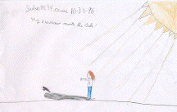
In the previous activity, students saw how shadows changed during a day. This activity uses a globe and indoor light source to create a classroom model showing day and night on a spinning Earth.
This activity requires a darkened room.

Materials:
Earth globe;
strong focused light source (such as an overhead projector or a slide projector); golf tees or paper clasps to create shadows on globe;
small figurines;
fun tack or similar material for each group of five if possible;
a picture of Earth taken from space can be helpful.

- Set up the light source so that it can shine from left to right across the front of the classroom, without blinding any students with its glare. The students should all be able to see the globe, when held in the beam of light, from about the same direction so that they can see both the illuminated and the dark side of the globe at once.
- Show students the globe and discuss its use as a model for the Earth. Explain the idea of scale. You can suggest that if the globe were the real Earth, they would be rather large, since they are far larger than the globe! Mark your geographic location on the globe. One of the first concepts that need to be understood is the effect of the Earth’s shape on our ideas of orientation. The globe should be held with the North pole approximately at top; for today’s purpose the tilt of the axis is irrelevant. Use a figurine to represent a person standing on the Earth near the North pole. Ask students where the person would be looking if they were to look “up.” Where would they look if they looked “down?”
For a person near the pole, these directions align quite well with “up” and “down” in the classroom, so they should see this. Now position the figure in the southern hemisphere, and repeat the question. There will be some confusion, and you will need to help them see that at any point on Earth, “up” is the direction away from Earth, while “down” is toward the Earth. It is sometimes helpful to show the figuring performing exaggerated “jumps” off the Earth and “falling” back to Earth, at various locations. Repeat this until students are comfortable with the relative nature of “up” and “down” on a spherical planet.
- Guide them through questions to the realization that if the globe in your hand were the real Earth, their location in class, off the Earth, would represent outer space. Encourage them to imagine they are out in space, and ask for some differences they would notice. You should get “no air,” to which you can respond by offering imaginary spacesuits; you may get “no gravity,” to which the response is that in fact gravity does extend to space, but is not felt in an orbiting spacecraft (only bring this complication up when necessary to correct a very pervasive misconception). Eventually, they should come up with “it’s dark,” at which point you can turn off the lights to simulate this situation.
- Ask then what they might see if they looked down at Earth from their location in space. Is the Earth glowing, like the Sun? The answer is no; the Earth is visible from space only because it is illuminated by Sunlight. Explain that we will use the overhead to represent the Sun today – note that unlike the real Sun this projects light only in a particular direction – convenient for our purposes today. Turn on the overhead. Half of the globe will seem to “glow” because Sunlight is reflected. Also, people on Earth can now see things around them because the Earth is illuminated. But not all people on earth. Not only half the Earth is illuminated. Place the figurine on the globe at a location where the Sun is “overhead.” Ask them whether the person can see the Sun, whether they create a shadow. Move the figurine to a location on the side of the globe away from the “Sun” and repeat the questions.
- It seems as though half of the world should be in perpetual darkness and half in perpetual light. Ask them why this is not the case. You should hear that Earth rotates, causing light and dark to alternate at each point. Attach a figurine to the globe at your location with fun tack. Slowly turn the globe from West to East so that the figurine "sees" the Sun rise in the east and set in the west. Have them identify a time the figurine would consider “day” and a time it would consider “night.” Ask them how long they think it takes the Earth to complete a full rotation; the relation to night and day should lead to the right answer.
- Now attach a second figurine to another part of the globe. Does the Sun rise earlier or later in this new location? Are the figurines always both in light or both in darkness? Or can one be in light while the other is in darkness? What if the two figurines were on opposite sides of the Earth? Explain the concept of time zones and the reason day at your location is night at other locations on Earth.
- Attach a golf tee to the globe at your latitude. Again, slowly turn the globe eastward and notice the fan-like shadow pattern that the golf tee casts. Is it similar to the pattern cast by the shadow stick in the previous activities? Note that the shortest shadow points towards the North Pole.
- Ask, “Have you ever been on a smoothly riding car or train and looked out the window ad it looked like everything on the outside was moving and you felt like you were standing still?” Describe now how in the same way because we ride on the spinning earth it seems the Sun and the stars are moving as day and night changes and we fell we are staying still. Do you feel the earth move? But in fact we are rotating on our axis at close to 1,000 miles per hour. Get the Earth to rotate slowly and ask them “How long it takes for the earth to rotate once?” Ask “when you are on a carousel and you look at the carousel horse you are riding, does it appear to be moving?” After some confusion, they should realize it will appear to be moving up and down only. Ask “if your mother is waiting near the carousel, does she appear to be moving?” They should discover that objects off the carousel appear to be revolving around it, in a direction opposite to the direction in which the carousel spins. If Earth is like a carousel, what should we notice about things that are “off the carousel?” Ask them to name things that are not on Earth; try to get them to realize that the apparent motion of the Sun (and all other objects in space) is precisely of this nature.
- Attach three golf tees to the globe at various latitudes along the same meridian of longitude. One should be on the equator, one should approximate your latitude, and one should be near the poles. Ask three students to each observe one of the golf tees. As the globe slowly spins, ask the students to call out their golf tee- "top", "middle", or "bottom"- as they cross the day-night boundary. Also, be sure to observe the midday shadows and to note in which direction they point.

Discussion:
How do we know if we're spinning the globe in the right direction? Where does the Sun rise if we were standing on the globe? Where does it really rise? Set? What if we spun the globe in the other direction? Would this also match our observations? It is only by such comparisons with observations that we can verify our models. Are the golf tee shadows longer or shorter at the equator? What about at noon, when the Sun is highest in the sky? Is there any shadow at the equator? What about at your latitude? Where do all the shortest shadows point? Does the pattern made by the golf tee reasonably match that made by the shadow stick of the previous activities? Might a spinning earth, then, not be a reasonable model for the passage of day and night? What if the Earth didn't rotate? What if the North Pole were pointed towards the Sun? Where would it be day and night? Would all locations still have both day and night?
Can you think of any other ways to test this model of a spinning Earth? Maybe shadow stick patterns from schools at other latitudes could be compared to yours. Are they consistent with the differences seen on the spinning globe? Have the students observed any complications that our model does not account for? (More on these, such as the tilt of the Earth in the next chapter.)
A useful and fun activity connected to this lesson would be to compare livecam pictures at one time from various locations on Earth, providing a concrete realization of the idea that time of day differs. A game of comparing predictions using the globe with observed conditions can be constructed. Internet Live Cam address:
http://www.rt66.com/~ozone/cam2.htm

Name _______________________________________________

Day and Night

In each of these pictures, we see the Sun on the left and the Earth on the right. We are looking down at the Earth from above the North pole. The arrow shows the direction of Earth’s rotation (to the East).

- Sunlight will hit one side of the Earth. Color the part of the Earth where it is day in yellow, and the side of the Earth where it is night in black.



- Draw a stick figure on the Earth where it is noon, so that the person would see the Sun right over their head. Will the person make a shadow?

____________________________________________________________

- Draw a stick figure of a person for whom it is morning. Will the person make a shadow? Draw an arrow to show the direction of the shadow.



- Draw a stick figure of a person for whom it is evening. Will the person make a shadow? Draw an arrow to show the direction of the shadow.

- Draw a stick figure of a person for whom it is midnight. Will the person make a shadow? Draw an arrow to show the direction of the shadow.

Daily Monitoring of Sunrise and Sunset Times
The tilt of the Earth in its orbit about the Sun affects not only the intensity of the solar radiation at a given location, but also the number of daylight hours. These two effects combine to create the weather we usually associate with each season.
In the Northern Hemisphere, the Summer Solstice (longest day, shortest night) occurs around June 21. From June 21 to December 21, the days grow shorter and the nights longer. There are two equinoxes, during which the hours of daylight and night are equal: the Vernal Equinox (around March 21) and the Autumnal Equinox (around September 22). One can observe these changes by recording the times of sunrise and sunset and measuring the length of the day. Changes in these times are large enough (about a minute a day) to be seen on a graph. The figure below shows such a graph made from sunrise and sunset times at the National Optical Astronomical Observatory located on Kitt Peak near Tucson, Arizona for September to December. If begun in September and continued through the Winter Solstice (about December 22), the graph should show the gradual decrease in the number of daylight hours (in the Northern hemisphere) with the minimum at the Winter Solstice. It would be interesting to include either of the equinoxes on the graph as well.
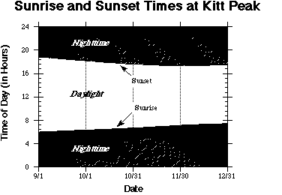
Materials: Large paper from roll (3'X6'); markers; yardstick; pencil; circle labels; paints; adhesive dots; daily local newspaper.
- 1. On a large sheet of paper, make a grid on which to plot the sunrise and sunset times. The time of day should run along the vertical axis, leaving about one inch for every hour. The date of the observation will be recorded along the horizontal axis.
- 2. Look up the times of sunrise and sunset in a daily newspaper. Plot these times on the graph, marking the points with adhesive dots. After plotting for several weeks, connect the dots with a line.
- 3. Optional: These coordinates can be stored and plotted with a computer spreadsheet like AppleWorks.

Discussion
The figure below shows a plot of sunrise and sunset times taken once a week from September through December. Notice that the shortest day occurs around December 21, as expected. In order to reinforce the connection between the number of daylight hours and average daily temperature, try making a wall-sized chart combining sunrise-sunset data with the daily temperature, as collected in the previous activity. While daily fluctuations in the temperature will be apparent, it is the general trends, which we seek. How does the length of the day change with season? Does the daily temperature match this trend also?

Recording Daily High and Low Temperatures
Weather is the result of an almost incalculable number of events. As such, it would be folly to attempt to predict a given city's temperature for a given date, far into the future. It would be equally foolish to point to an exceptionally cold day in June and declare "Winter's coming!" There are just too many variables for such a simplistic view. However, hidden among the randomness are trends which can be measured, and from which conclusions like "winter's coming" can be made.
The class can measure the outside temperature at a particular time each day, perhaps noon or lunchtime. From newspapers or broadcast newscasts, the class can collect local high and low temperature readings for each day. These can be plotted on a graph or entered into a database. For younger students, a classroom chart with cartoon thermometers with daily temperature marks can be made. The exact form of this activity is not important. One should emphasize the importance of recording data in an appropriate way. Sometimes making a simple graph can explain pages and pages of numbers. Simplicity is the key. With clear presentation of data, it is much easier to move forward and, for example, correlate the temperature measurements with the shadow stick and dome measurements.

Resources:

Everyday Classroom Tool’s: Chapter 2 The Earth’s Orbit
http://hea-www.harvard.edu/ECT/the_book/Chap2/Chapter2.html

The Reasons for the Seasons

Purpose:
What causes the seasons to occur and change? What allows for the seasonal changes to be consistent year after year? Although we witness and experience seasonal weather and temperature changes yearly, we grapple with understanding why and how the Seasons occur. This demo activity displays how the Earth’s orbit around the Sun and tilt on its axis effect the seasons. Students will begin to explore how the Earth’s tilt determines the fact that while the Northern Hemisphere has summer, the Southern Hemisphere has winter. Additionally, students will be lead to understand the fact that during the Northern summer the North Pole is tilted towards the Sun and during the winter, it is tilted away. Your students may need further exposure to these facts and demos over the years but their initial exposure in The Reasons for the Seasons Activity will help them visualize the causal link between the Earth’s tilt and orbit and our seasonal changes.

When asked “What makes the Seasons occur?” some of your students (and most adults) will answer by describing the differences in temperature and weather from season to season. Additionally, many believe the Earth is closer to the Sun in summer than winter thus causing the higher temperatures. If you remember back to the activity The Sun Moves in the Sky! you will notice the arc of the sun across the sky changes as the seasons change. The Earth’s tilt causes the sun to appear higher in the sky during the summer and lower or closer to the horizon during winter. The higher the Sun appears in the summer sky the longer the amount of daylight and that translates into more intense, direct sunlight to cause hotter temperatures. The connection between the Earth’s tilt, the length of daylight and the temperature in each hemisphere is dependent on this not so-normal merry-go-round ride Earth travels on year after year as we rotate around the Sun.
Materials:
-Globe
-lego persons, golf tees or other small items to act as a human on the globe
-portable ibook computer cart or do activity in the computer lab
-clay or other sticky material to attach small items on globe
-Lamp or another 360-degree light source (best if you have 350 watt bulb)

Inquiry Activity:
Preparation:
Post your class’s The Sun Moves in the Sky! arc drawings from as many seasons as possible. These arc drawings will be helpful to have posted for students to reference as they discuss their understanding of how the Earth’s axial tilt affects the changing amount of sunlight and position of the Sun in the sky. If you have more than one season’s arc drawing this is ideal because the students will begin to better understand that the Sun’s path does not stay stationary all year long. Connecting the Sun’s apparent path using their arc drawings to the changing amount of sunlight and then finally observing the earth’s orbit and axial tilt in this lesson’s demonstration will provide the needed facts for the students to begin to piece together The Reasons for The Seasons. Additionally, if your class has recorded the daily changing sunrise and sunset times (see the above supplemental activities for Day and Night on the Spinning Globe) have them posted for students to reference as they discuss their explanations for the reasons for the seasons. Combining your changing temperature charts with your sunrise and sunset charts will underscore how the tilt of the Earth in its orbit about the Sun affects not only the intensity of the solar radiation at a given location, but also the number of daylight hours. These two effects combine to create the weather we usually associate with each season.
Be sure to position the lamp or light source in the center of the class and if possible have the class sit in one section or corner of the class to provide similar perspective for each student.

Activity:

- Set up your lamp’s bare bulb as the Sun in the middle of the room so that you are able to walk around it to demonstrate the Earth orbiting later on. An ideal setup would have the kids sitting close to each other in one area of the class – some classes are better set up for this than others, so you will need to improvise here. Begin with a reminder of the last lesson Day and Night on the Spinning Globe and what they learned about day and night and the Earth’s rotation. Use your little toy (anything small will do e.g. lego person) to show your positions on Earth. Place your person on the globe and review day and night on the spinning Earth. Place a small object on Durham and facing the light source. Ask, “Is it day or night for the person? How do you know?” Ask, “Can someone come up and rotate the Earth so that the person in Durham is experiencing night? And explain how you know this.” Have someone come up and place a small object on the globe to represent a person who is experiencing day when Durham’s person is in the dark of night. Next, you can have Durham be positioned at noontime and ask the kids to name another place on the globe and figure out if they are in light or darkness. It’s always helpful to get world locations by asking the kids where members of their families live outside of the US or what countries their families moved from before the US. Remember to turn Earth West to East (which looks counterclockwise when you look down at the North pole)! Mention our story from the end of the last activity about living on a carousel or merry-go-round called Earth, moving at 1000 mph around equator, so that everything off Earth seems to be rotating.

- While on this subject, you may as well bring latitude into the story. Ask them where on Earth you can ever see the Sun directly overhead. In our current model the answer is the Equator. To see this dramatically, attach another small object at the North Pole and have them find out that he now sees the Sun on his horizon, and its motion for him is completely horizontal. Show them how at intermediate latitudes he sees the Sun move in the sky in a circle tilted by his latitude. It is not necessary to go into the mathematics of the angles here, the point it that the farther from the equator you go, the flatter the Sun’s motion in the sky and the lower it stays.

- Ask, “Can someone explain what makes night cooler than daylight hours?” You are looking for the obvious answer of no direct sunlight. Next ask the students, holding Earth vertically (no tilt on the axis), “Is there a longer amount of light hours or dark hours?” There will be differing answers here, including I am sure some referring to seasonal change. Try to get them to admit that as your model stands now, everyone on Earth should see 12 hours of light and 12 of dark, except maybe at the poles where you get perpetual twilight.

- They will likely have told you already that this is not the way things are, people all over Earth don’t have 12 hours of light and darkness everyday of the year. See if they can tell you why they think this is. If your class has measured daily sunrise and sunset times as well as taken arc drawings of the sun’s path across the sky, I imagine they will include their understanding of these phenomena and their causes (the earth’s tilt and orbit around the Sun) in their explanations. You are likely to get a correct answer here, but do not assume they all get it because one does.

- Ask the students, “What makes the days warmer because you will agree the days are warmer in summer?” Some students may claim that the earth is closer to the Sun in summer. Be sure to ask those students the follow up question, “Does all the Earth have summer at the same time?” Some will shake their heads no as they remember that some parts of the world have winter when we have summer. Now allow the students to use the web live cams from places throughout the globe. Discuss what season it is now at school and to look for signs of what season it at each live cam location. It is helpful to choose city locations close to our longitude because the time zone will be similar and it will be daylight outside. Have the students search the following locations on http://www.rt66.com/~ozone/cam2.htm

        - Prince Edwards Island, Canada, North America, Northern Hemisphere http://www.gov.pe.ca/islandcam/
        - Santiago, Chile, South America, Southern Hemisphere http://www.cybercenter.cl/html_cyber2/live_cam/live_cam.php
        - Atka Bay, Antarctic http://www.awi-bremerhaven.de/NM_WebCam/

- Looking at the site from Santiago, Chile will provide a picture of a site that is in the opposite season. So, if we are in winter, Santiago will be in summer. Don’t mention “hemispheres” just yet and see if the students can detect a pattern based on locations of hotter or colder looking live cams. If it noticed that one half of the globe is experiencing on season and another portion of the globe is experiencing another ask, “How is it this could happen?”

- (If the students are unable to use the web live cams especially due to Internet regulations prohibiting any live cams on school computers that’s fine. Skip and go to #8)

- Ask the class “Is there a way to make one part of the globe colder than another? Can anyone move the globe around to try it out? Is it possible to make one half of the world get warmer than the other?” Of course, the day side of Earth is warmer – the point here is to make one part of the Earth warmer on average than another, even as the Earth rotates. Some may suggest tilting the one half away or towards the light to make it warmer. If they don't suggest tilting the Earth, tilt it yourself and ask, “What happens to the different parts of the Earth if it were tilted like this?” How warm could this part get as compared to the other part? Continue by tilting the Earth (by about 45 degrees) so the Northern hemisphere faces them. Point out how most of what they see is the Northern Hemisphere. Show how as you turn the Earth about a tilted axis, there are some points (down to latitude 45) that they can see at all times; some points (latitudes near the equator) they can see for part of the time; some parts of Earth they do not see (south of latitude –45). Note that as Earth turns, points in the North are visible for more than ½ the time and points in the South for less.

- We are going to create an Earth orbit inside the class. Pick a particular direction in the classroom (typically towards one of the walls) where the Earth’s North pole will point. Section of orbit near that wall will correspond to December. For this step, you want to be 180 degrees away (near the opposite wall) so it is June. Now make the connection to the Sun and the tilt of the Earth’s axis relative to its orbit. Start with the Northern hemisphere pointed towards the Sun; exaggerate the tilt as above. Show them that days are longer than 12 hours in the North, shorter in the South. Make a connection to more Sun means warmer. This is summer in the Northern hemisphere, winter in the South. Show them how north of the arctic circle the Sun does not set, just as they could see points near the pole at all times. South of the Antarctic Circle the Sun never rises.

- What happens to change the seasons? Try tilting the Earth in another direction. Now South faces the Sun, so this would be winter for us, and summer in the South. Is this what happens? It could be but it isn’t. In fact, Earth’s axis points in same direction at all times. What does change is where Earth is relative to Sun. Our merry-go-round ride is even more interesting. Go 180 degrees on orbit, to get to point where it is winter in north, summer in south. Get them to guess what month this is. Tell them of Christmas in the summer in the southern hemisphere. Yes, people swimming at the beach on Christmas and in January. Now go 90 degrees around, show them the (spring) equinox when day and night are equal in length. Ask them when this happens. In fact, the spring equinox the next two years (2004-5) is on March 20. So days and nights will be about equal everywhere on Earth. Ask them where else in the orbit this happens. They should find this 180 degrees away, the location of the fall equinox, around September 20.

- Go around an entire orbit once more, get the students to figure what month and season it is in the north and south part of the Earth. Give the students an Earth Styrofoam model one and stand them up in the position of their birthday in the Earth’s orbit around the Sun. In the end you should have all the kids standing around the class making up parts of the Earth’s orbit and have people in every season. (See the attached Daylight Changes Math Activity for fun daylight and calendar math word problems). Have the students identify what season they are generally in. e.g. summer, fall… Next, ask the students if they are in summer to move into the area of the next season, Fall. As an entire class have each season move to the next season’s zone in the Earth’s orbit. Continue so the students rotate for one whole year. Be sure the direction of axial tilt for each student’s Earth is in the correct position as it orbits the Sun (e.g. Northern Hemisphere tilted towards Sun in summer months, and away in Winter).

- Show them Arctic and Antarctic circles, as well as the tropics, places where Sun gets overhead every day in the year. More importantly, show them how for us the Sun gets higher overhead in summer but tilts farther south in winter and farther north in southern hemisphere. If they have already done Sun path arc drawings reinforce the data collected on the arc diagram and ask them to figure out what it will look like in another season or if they were in the Southern Hemisphere.

- Distribute the What Season in the Orbit? worksheet and explain directions. At a point when most students are near completion, review their answers and explanations. It is helpful to make an overhead reproducible of the worksheet and review the students’ responses together as a class. Invite students to come up and draw in their drawing of how the Earth is tilted in each season on the overhead transparency. To verify the correct responses and descriptions for where the Earth is tilted look at http://hea-www.harvard.edu/ECT/pdf/sunearth.pdf.

You may wish to extract a vocabulary activity from this unit: solstice, equinox, tropics, Arctic/Antarctic circle, Hemisphere.

Seasons

- As the Earth orbits the Sun, the tilt of its axis means that at different places along its orbit either the northern hemisphere, the southern hemisphere, or neither is pointed towards the Sun.

- When the northern hemisphere points towards the Sun, the weather here in the north is warm, days are long, and it is summer. At the same time, in the southern hemisphere it is winter. The time of year when our day is longest, and the day in the southern hemisphere shortest, is the summer solstice, around June 20.

- When the northern hemisphere points away from the Sun, our days are short and our weather cold, it is winter. In the southern hemisphere, it is summer. Days are long and the weather warm. Our shortest (and their longest) day occurs at the winter solstice around December 21.

- In between these, there are two days a year when day and night are of equal length everywhere on Earth; these are the spring equinox around March 21 and the fall equinox around September 22. Note that in the southern hemisphere the fall equinox occurs in spring!

- Cut out the four pictures of the Earth in the dark sky and glue them in place at the four points along the orbit in the first picture. In this picture we are looking at the Earth and Sun from the side.

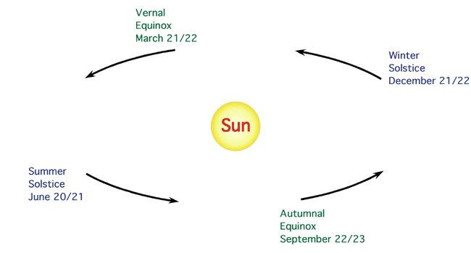

- Cut out the four pictures of the Earth on a white background and glue them in place at the four points along the orbit in the second picture. Here we are looking at the Earth and Sun from above the Earth’s orbit. The green dot on the Earth is the North pole.
Spring Equinox
March 21/22
Winter Solstice
December 21/22
Summer Solstice
June 20/21
Fall Equinox
September 22/23
Daylight Changes
As the Earth orbits the Sun and spins on its axis, the amount of the Sun’s light changes everyday. From the summer solstice, the day each year with the greatest amount of daylight, in the middle of June (around June 22) to the winter solstice, the day each year with the least amount of light, in the end of December (near Dec 21) day light gets shorter and shorter each day. Below try your math skills at figuring out how much longer or shorter the amount the Sun’s light is hitting the northern part or hemisphere of the Earth.
From the winter solstice around December 22 until the summer solstice around June 22, each day has approximately 2 minutes more sunlight than the day before. Solve the winter and spring math problems below using both number sentences and word sentences.
- How many more minutes of sunlight will March 21 have than March 5?

- How many more minutes of sunlight will April 5 have than March 26?

From the summer solstice around June 22 until the winter solstice around December 22, each day has approximately 2 minutes less sunlight than the day before.
3. How many fewer minutes of sunlight will December 5 have than November 27?

- How many fewer minutes of sunlight will August 21 have than August 5?

Phases of the Moon

Purpose:

Phases of the Moon are not caused by the Earth’s shadow. They are due to a change in our viewing perspective as the Moon orbits around Earth and is lit by the Sun. The Sun lights up half of the Earth and Moon just the same way a flashlight lights up one half of a ball. The Earth spins in the light, so that the entire Earth gets to be lit at some point of each day. At any point in time, we on Earth can see exactly one half of the surface of the round Moon. How much of the half we can see is included in the half that is lit by the Sun – and hence visible – depends on the relative positions of the Earth, Sun, and Moon. As the Moon orbits Earth, the change in relative positions gives rise to the varying phases. Because the phases are caused by the relative direction of Moon and Sun in the sky (as seen from Earth) they are related to the time of day when the Moon can be seen in the sky. A full Moon always rises at sunset while crescent Moons are visible during the day. The Moon’s orbit is a little bit tilted, so sunlight shining around the Earth reaches the Moon when the Moon’s tilt puts it above or below the plane of the Earth’s orbit. Otherwise, the Moon would be eclipsed every month when it moved into the Earth’s shadow! This activity will allow the students to physically manipulate a Moon/Earth/Sun model to create and identify all of the Moon’s phases.

Materials:
  - Strong light source i.e. lamp without shade
  - Earth globe
  - Extension cord
  - Two inch Styrofoam ball for each student
  - Pencils
  - Worksheet

Inquiry Activity
- Darken the classroom and use an extension cord to enable light to be placed in middle of room. While holding an Earth globe in your hand review what they know about how day and night is caused on Earth with the students. Refreshing their memory about how the Earth’s rotation causes day and night is useful both for the analogy to how the Moon shines and to understand why we see it at different times. Give them a few minutes to ask questions about past material. Stop this before the questions degenerate to complete irrelevance.
- Students imagine that their heads are Earth and the light in the center of class is the Sun. Explain that each student will be given a model of the Moon to add to his or her Sun/Earth System. Now start talking about the Moon. Ask, “What does the Moon look like?” Summarize the discussion by pointing out it seems to change shape. Now ask, “What is the Moon made of?” Ignore the cheese joke and get to rock. Ask, “So how does a chunk of rock change shape? Summarize by describing that the Moon does not change shape but it looks as if it does. Explain that today we’ll figure out how this works.

- Ask, “How does a chunk of rock shine so brightly that we can see it?” Let them get to the fact that the Sun shines on the Moon, making it look bright in the sky. The students should understand that the Moon is a ball of rock, which shines because Sun lights it up. Remind them how, when Sun shines on Earth, it is light (daytime) on half of Earth, and dark on the other half. So it is on the Moon as the Sun can only make one-half shine, the other is dark.

- Arrange the students in a circle around the “Sun,” leaving ample space between them. Explain that in today's exercise, their heads will play the role of the Earth. They can imagine a town called Eyeville, located in their right eye and populated by Eyevillians. What their right eye sees will reflect what the Eyevillians can see. Ask them all to “turn around until it is noon in Eyeville.” Continue with this type of exercise until they are comfortable with the idea of their head as Earth, and have demonstrated an understanding of the lessons of Day and Night on the Spinning Globe.

- Hand out a Styrofoam ball and pencil to each student and have them mount the ball on the pencil, which they hold in their hand like a lollypop. The balls will play the role of the Moon (if the Moons are pockmarked from previous use, explain that this makes for realistic Moons with craters). They hold their Moon at arm's length right in front of the sun.

- Students move the ball a little to the left of the sun looking at the moon until they can see a crescent shape in light. Get them to figure out if this crescent is facing the sun or away. Ask, “What side of the Moon is lit? The side that’s closer to the Sun or further away?”

- Students keep moving their moons around their heads (Earth). They stop when they can see half the Moon lit. Ask, “As the moon grows fuller is it moving towards or away from the sun?”

- They move the Moon in a circle until they can see it fully lit. To accomplish this, they must hold the moon above their heads. When they observe the ball fully in light ask. “Describe where the Moon is located in the Sun/Earth/Moon system?” Is it between the Earth and the Sun or on the opposite side of Earth from the Sun?”

- Students continue to move the moons until they are half full again. Ask, “As it moves toward the Sun is it getting fuller or thinner?”

- Have them move their moons so that they become crescent slivers. Then explain that when the moon passes the sun it usually is just above or below it and we cannot see it. Why not? This is the phase we call the “New Moon”. It is called “New” because the ancients thought it was newly born each time.

- Repeat this activity several times making sure that the light source is appropriate so that the phases can be clearly seen. Have students do this for a few minutes for themselves, then call out commands and see if they can all do “full moon”, “half (or quarter – whatever you have called it to them) moon”, “banana moon”, etc. The idea is that they should be able to see the shape of the Moon and move themselves until they see the shape you asked for. Keep this going for a few minutes and move around to see if they really did get it. You may want to show them how smaller phases happen when Moon is near Sun in the sky. Ask, “At what time of day will you see a Full Moon directly overhead? Where is the moon when it is the smallest phases or shapes? At what time of day could you see a ‘Banana’ or crescent Moon?” Talk about how the Sun’s light complicates seeing certain phases of the moon.

- Someone will make an eclipse, inadvertently, while doing this, and they may ask what happened. Tell them this is cool, we’ll talk about it next week, but for now show them how holding Moon a bit higher to keep it out of shadow of their heads will eliminate the problem.

- Explain the Moon Phases Worksheet and complete Moon Day 1 and Day 7 together as a whole class. Use the directions below. Have an overhead transparency of the workshop to use with the whole class. Once most of the class is completed review their answers and explanations. When finished the worksheet ask, “How long from Full Moon to new Moon? How long is one lunar cycle? Is it possible to have two full moons ever in one month? If so, how could this be possible?

Moon Phases
New/Waxing/Full/Waning

- Sunlight hits one side of the Earth, making it day there. Color the half of the Earth where it is day yellow.

- Sunlight also hits one side of the Moon. For each Moon in the picture, color the half of the Moon that faces the Sun yellow. [This half of the Moon will glow in the sky because much of the sunlight hitting it is reflected back into space.]

- When we look at the Moon from Earth, we can only see the side of the Moon that is facing us. For each Moon in the picture, color in blue the one-half of the Moon that can be seen from the Earth.

- When we look in the sky, we can only see the glowing part of the side of the Moon that is facing us. That’s the part of the Moon that is colored in yellow and in blue. This has a different shape for each of the Moons in the picture, so people looking up at the Moon from Earth will see a different shape depending on where the Moon is. Write the phase you think the Moon will be under each Moon.

- Draw a line from the center of the Moon on day 1 to the center of the Earth. The line touches the Earth where someone standing on the Earth will see the Moon directly overhead. For which of the six positions will the Moon

be visible in daytime? __________

be visible at night? ___________

be visible at dawn or dusk? __________

6. Which day corresponds to the new Moon? ___ The full Moon? ____

Which to the waxing Moon (the illuminated area getting bigger)? ______

Which to the waning Moon (the illuminated area getting smaller)? _____
Moon Phases in the Orbit
Day 1

______________
Day 25

_____________
Day 5

______________
Day 8

_________________
Earth
Day 22

_____________________________
Day 19

_____________
Day 15

_________________
Day 11

____________
View of the Moon from the Earth

You are now on the Earth looking at each of the Moons shown in the previous diagram. Outline the area of the Moon that is bright from your viewpoint on the Earth. Fill in with a pencil or crayon the area of the Moon that remains dark, or else cut and glue the correct picture of the Moon in each position as it would look from Earth.

Day 22

Day 25

Day 11

Day 5

Day 1

Day 19

Day 15

Day 15

Day 8

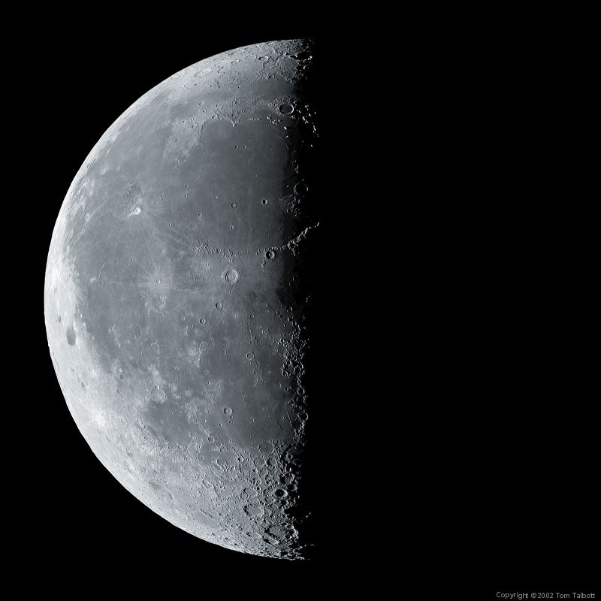
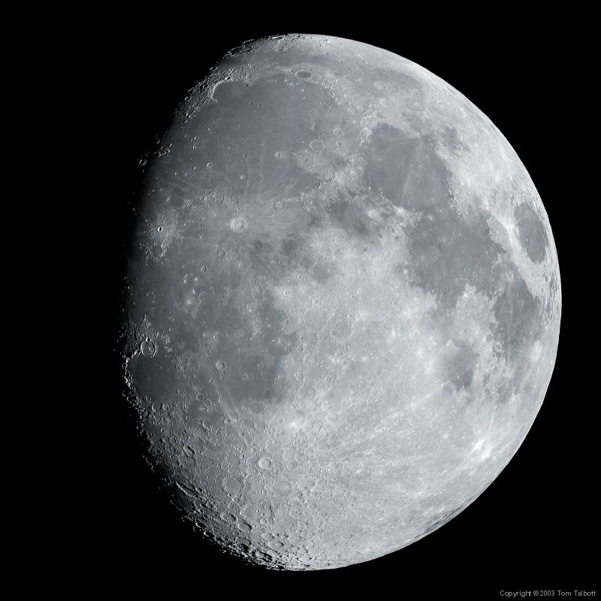
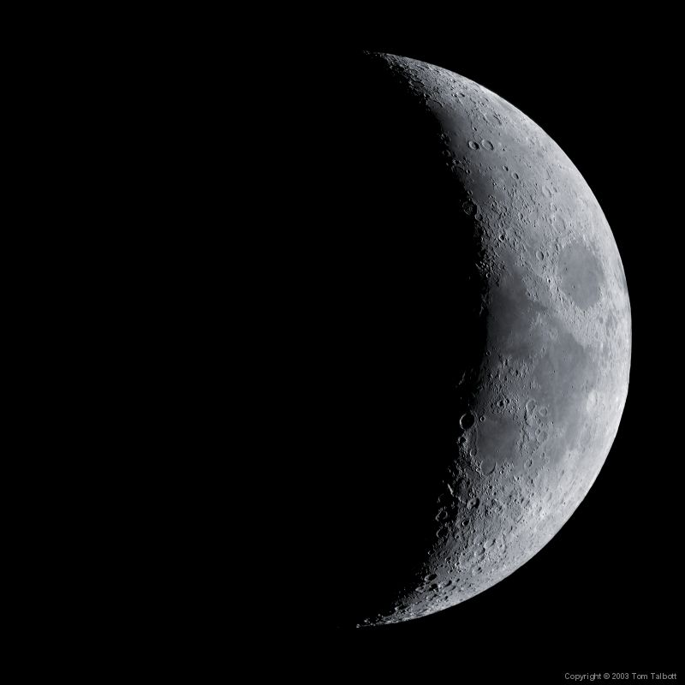
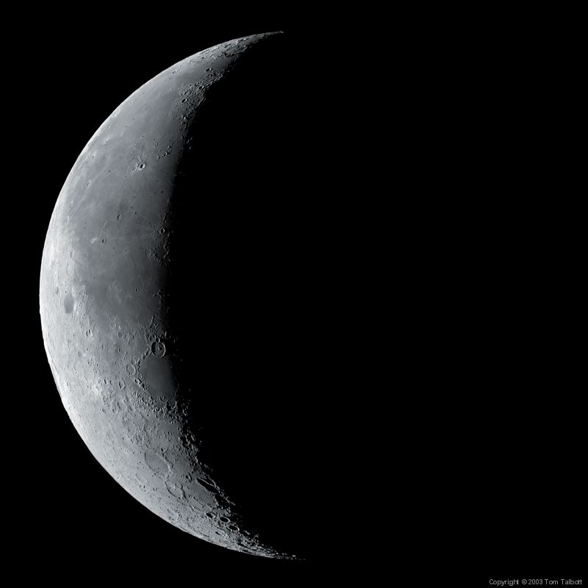
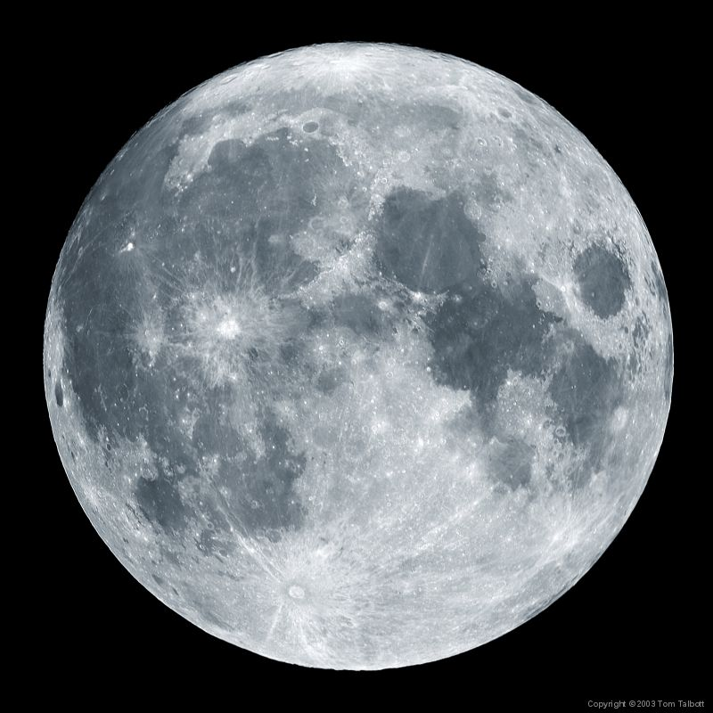
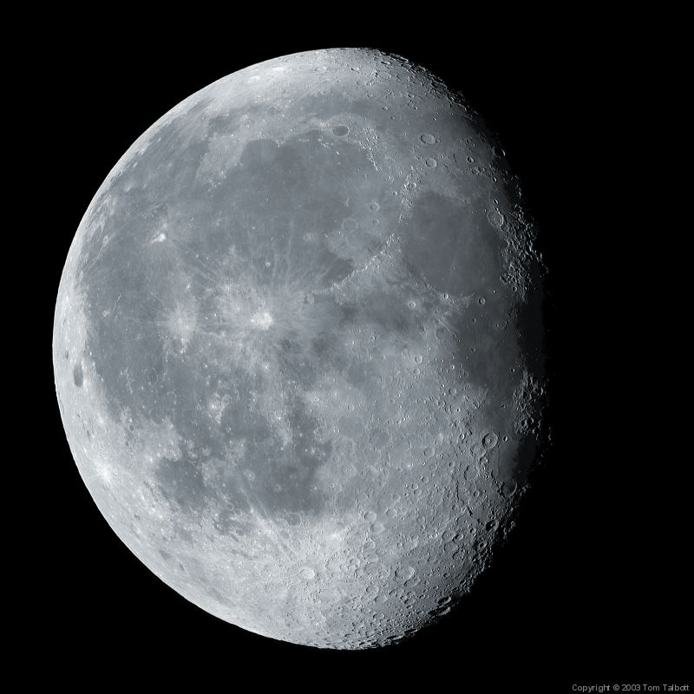
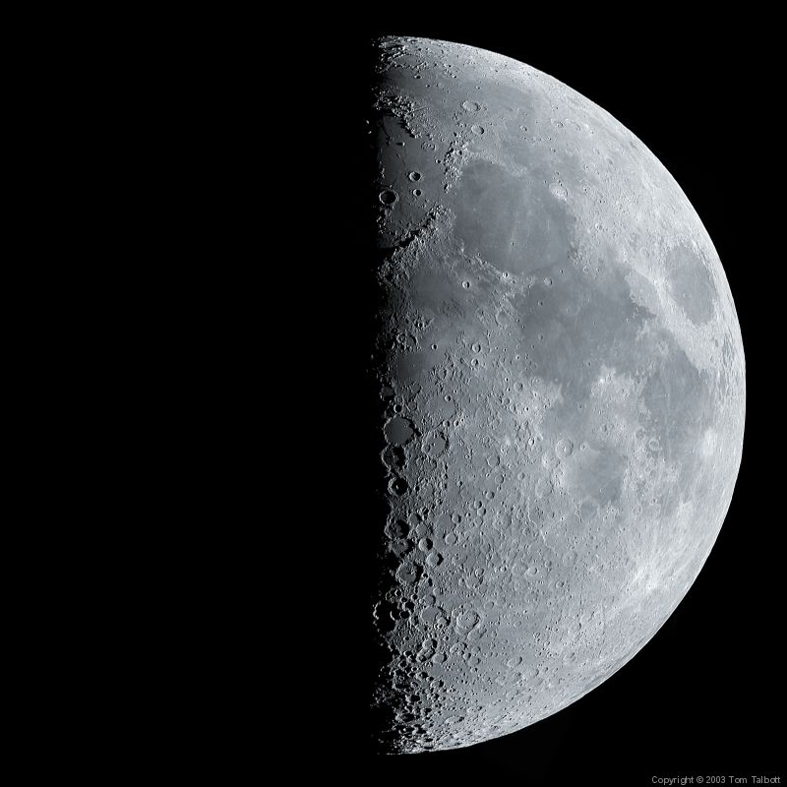
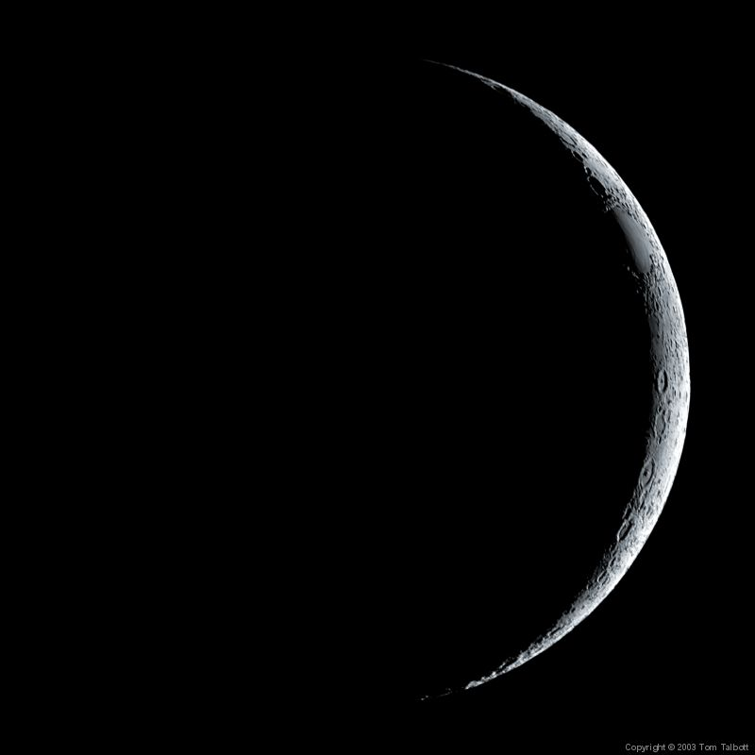

Additional Activity: Observing the Moon’s Phases and Motion

Taken from the Activity Observing the Moon’s Motion found at

http://hea-www.harvard.edu/ECT/the_book/Chap6/Chapter6.html#otm

For many cultures, the Moon became an essential tool for survival. Observers of the sky noticed that the Moon's movements were not random and fit a pattern. This pattern would be the foundations of the first calendars (see Chapter 3), and would aide early farmers in predicting planting and harvesting times, or help those living in flood plains of large rivers to be prepared for the rainy season. The moon's regimented pattern can be seen over days and over months in its shape, height in the sky, and location.
Now that the students have seen a simulation of the moon in orbit about the Earth, they should be ready to make actual observations and ask logical questions.
Questions to ask: How does the moon change from day to day? Is it possible to see the moon in the daylight hours? Is there any pattern to the various shapes of the moon? How often does a full moon occur? How could we observe and record the shape and placement of the moon in the sky? When during school hours could we begin this study based on information given in the introduction?
Materials: Sheets of paper 8 1/2" x 11" for each student or small group; heavy cardboard (approximately 9 x 12) for each student or group; pencils; folder such as file folder to store recordings in; Large chart 3' x 6' from standard role; markers; diagram of moon phases; compass.

Morning Observations
Never look directly at the sun.
Begin three days after full moon.
Before beginning this activity, check on the position of the moon and whether it is obstructed. Look for the moon in the western sky.
1. Students should practice measuring techniques in classroom. Stand with arms raised above heads. Hold one hand blocking an imaginary sun to protect eyes. Form a fist with other hand and point the wide part to the sun. Move the fist toward the moon counting each fist placed. Practice several times.
2. Measure and draw the moon's shape and position in relation to the Sun. Find a place to stand facing South. On the recording sheet, students should place an S in the middle of the top of the paper, E on the left hand upper corner, W on the right hand corner and than draw the horizon leaving a large space for the sky.
3. Observe and record daytime moon and sun every other day (does not need to be at the same time) labeling each drawing with the date of the observation and the distance between the moon and sun measured in fists.
4. Discuss the changes in shape and distance from sun after observations. After each observation, ask students if the curved part of the moon is facing toward or away from the sun. Ask them to predict where the moon will be after a few days and also to predict how far from the sun it will be in fists.
5. After about five measurements, the observations may be summarized on a large sheet of paper. The moon is no longer visible during the morning ten days after the full moon. Place a large chart on the wall. Draw or have students draw horizon objects and label directions. Start with the first observer. Ask the students to use their observation sheets to describe the shape of the moon on that day. Have them share their fist measurements and use the average of these. Draw the sun and moon as they looked on the day of observation. Write this date and the number of first measurements under moon. Record all other observations in fists and shapes.
Evening Observations
1. Students should think about and discuss why the moon is no longer visible during the day. They should think about and predict when and where it will be visible again.
2. Two or three days after the new moon, students watch at sunset to see when the moon first appears near the setting sun. It will appear as a thin crescent. They record the setting sun and then draw the moon every other clear day at sunset with the date and fist measurement from setting sun to moon and the fist measurement from horizon. They do this on clear days until the full moon which is about two weeks after the new moon and add their recordings to their folders.
3. Place another large sheet of paper on wall and draw observations as in daytime observations showing number of fists away from moon to sun, number of fists from horizon to moon, and the date of observation.
Discussion:
Discuss observations and the moon's shapes at different times. What patterns have they observed? Can we predict if this pattern will be recurring? What will help us to decide that? What use could we make of this recorded information? How were these observations of the moon helpful in earlier times? Might the phases of the moon contribute to the understanding and ordering of the ancient world?

Where Did the Moon Go?

Eclipses Activity

Purpose:

The phases of the Moon occur because of changes in how much of the Moon’s surface we see lit up. The Earth’s shadow plays no role in the Moon’s phases but… our shadow does darken the Moon during a lunar eclipse. During the Where Did the Moon Go activity the students will find out why and how the Earth’s shadow blocks all or some of the Sun’s light from hitting the Moon, and how the Moon's shadow can prevent light from reaching some of the surface of the Earth.

Teacher background:

The Earth circles the Sun once a year in an ecliptic plane that contains the Earth, Earth’s shadow and the Sun. Our Moon that circles Earth approximately once a month orbits the Earth titled 5 from the plane of the ecliptic. Each month as the Moon is on the side of the Earth away from the Sun it passes close to an eclipse. There isn’t an eclipse every month because the Moon’s orbit is titled and that causes the Moon to pass above or below the earth’s shadow. The direction of the tilt of Moon’s orbit is itself changing (precessing). It turns out that the line of nodes, the line common to the plane of the Moon’s orbit and to the ecliptic, lines up along the Earth-Sun line once every 346.6 days. An eclipse occurs when this time coincides with either a full (lunar) or a new (Solar) Moon. Because 19×346.6 = 223×29.53 = 6583.3 days, an eclipse will be followed by another after this interval (the saros, 18 years, 11.3 months). This interval, discovered by the ancients, allowed them to predict eclipses. Of course, two solar eclipses separated by this interval will not be visible from the same place on Earth because of the .3 day; a repeat eclipse in (almost) the same location will happen after three saros intervals, or 54 years, 34 days. Alignment does not need to be perfect, and on average lunar eclipses occur 2-3 times a year and Solar eclipses about twice. Often the same near-alignment leads to a Solar and a lunar eclipse during the same month or eclipse season.

Because the full Moon is visible from one-half of Earth (the night side), everyone on the night side can see all or part of the lunar eclipse when it happens. During a total eclipse the Moon looks reddish-orange. The Moon’s deep orange color comes about as the earth’s atmosphere bends the red-orange part of the sunlight into the shadow (similar bending happens at sunrise and sunset when the sky appears red). The next viewable lunar eclipse in the North America is on October 28, 2004.

A strange coincidence allows the Sun and the Moon to appear to be the same size even thought the sun is 400 times larger than the Moon. The coincidence that makes this possible is that the Moon is also approximately 400 times closer to us than the Sun. Due to this coincidence, if the Moon where to pass directly between the Earth and the Sun, the Sun’s light would be blocked creating a solar eclipse. A solar eclipse happens when the Moon is on the same side as the Sun – the New Moon phase. And this too happens about once every six months because of the Moon’s tilted orbit but because the Moon’s shadow is so small only a small part of the Earth’s surface will see the Moon totally eclipse the Sun. Others see a partial solar eclipse that using the right technology will look like a bite was taken out of the Sun. The next viewable solar eclipse in North-eastern North America will be on August 1, 2008.

Inquiry Activity:

The idea in this activity is to reinforce the previous discussion of lunar phases, and to explain how eclipses happen. We will set up the class much the same way we did last time, with the Sun in the center.

- Start by reminding them of the lesson learned last week: the Moon changes shape in the sky because the angle at which the Sun illuminates it, relative to the direction from which we view it, changes as the Moon orbits Earth.

- Try to get them to figure out how the phases are related to the times at which we can see the Moon. New moons rise and set with the Sun. waxing half moons rise and set about 6 hours after the Sun so are best viewed in the afternoon, are highest in the sky at sunset, and set around midnight. Full moons rise at sunset and are up all night. Waning quarter moons rise six hours before the Sun so are best viewed in the morning and set around noon.

- Get them up in a circle around the “Sun” and lead them through making phases one more time. Point out how the shape correlates with the Moon’s position relative to the Sun. Have them imagine their head as Earth (this is important for the next thing!!) and have people living in Eyeville look up at the Moon at whatever phase they are making. Can the Eyevillians see the Sun? What time is it in Eyeville? (since they are turning to follow the “Moon” this is always at its highest point in the sky for the Eyevillians)

- Now we get to eclipses. Set yourself up with a “Moon” in front of a wall. Make sure they can see your shadow on the wall. Now show them how you can make a full Moon disappear, and discuss what has happened to the Moon – it has been swallowed in the Earth’s shadow (remind them that your head is Earth here). This is what we call a lunar eclipse. Show them this can happen only at full moon. Show them other phases and ask how Earth can shadow Moon (it can’t).

- Now have them make lunar eclipses. Show them how if you do it slowly (and in real time it does happen slowly – takes about an hour) you can see the Moon disappear one bit at a time.

- Get their attention again (ask them to put their hand with the “Moon” straight down so the thing is out of the way and not distracting them – and they can’t play with it). Show them how you make a solar eclipse by getting the Moon in front of your face. This works best if you hold moon closer to you, and close one eye – so you are looking from the point of totality. Make them look at your face as you do this and notice the dark circle where the Sun is hidden. Make sure they understand that people there will see their day darken – so first that it is day and second that Sun is hidden. Show how people elsewhere can still see Sun (rest of your face is not dark). Turn your head a bit to mimic Earth, show how eclipse moves along Earth.

- Have them make Solar eclipses, partner them up and have one make an eclipse while the other looks at them to see the dark spot on their face.

- Explain to students the Where Did the Moon Go? and Where Did the Sun Go? Worksheet. Post the students drawings and descriptive paragraphs around the room for students to observe when the activity if finished.

Where Did the Moon Go?

Each month as the Moon is on the side of the Earth away from the Sun it passes close to an eclipse. There isn’t an eclipse every month because the Moon’s orbit is titled and that causes the Moon to pass above or below the earth’s shadow. There is an eclipse about every six months causing the Moon to be partially or completely eclipsed by the Earth.

Below draw the Sun, Earth, the Earth’s shadow and Moon so that the Moon is being eclipsed by the Earth’s shadow.

Below describe what is happening in your picture above and how a lunar eclipse happens.

Where Did the Sun Go?

A solar eclipse happens when the Moon is on the same side as the Sun – the New Moon phase. And this too happens about once every six months because of the Moon’s tilted orbit. But because the Moon’s shadow is so small only a small part of the Earth’s surface will see the Moon totally eclipse the Sun. Others see a partial solar eclipse that using the right technology will look like a bite was taken out of the Sun. The next viewable solar eclipse in North-eastern North America will be on August 1, 2008.

Below draw the Sun, Earth, Moon, and the Moon’s shadow so that the Sun is being eclipsed by the Moon’s shadow.

Below describe what is happening in your picture above and how a solar eclipse happens.

